REG.NO: 22TD0053 NAME: MOHAMED B SIRAJUDDEEN YEAR/SEM/SEC: Y2/S3/B
LINEAR SEARCH

Source code:
#include<stdio.h>
int main()
{
int a[100],n,i,k,flag=0;
printf("\n\nLINEAR SEARCH\n\n");
printf("Enter the Number of elements");
scanf("%d",&n);
for(i=0;i<n;i++)
{
scanf("%d",&a[i]);
}
printf("Enter the element to search\n");
scanf("%d",&k);
i=0;
while((flag!=1)&&(k>=a[i]))
{
if(k==a[i])
{
flag=1;
printf("\nSUCCESSFUL SEARCH\n");
}

else
{
i=i+1;
}
if(i>n)
{
break;
}
}
if(flag==0)
{
printf("\nUNSUCESSFUL SEARCH\n");
}
return 0;
}

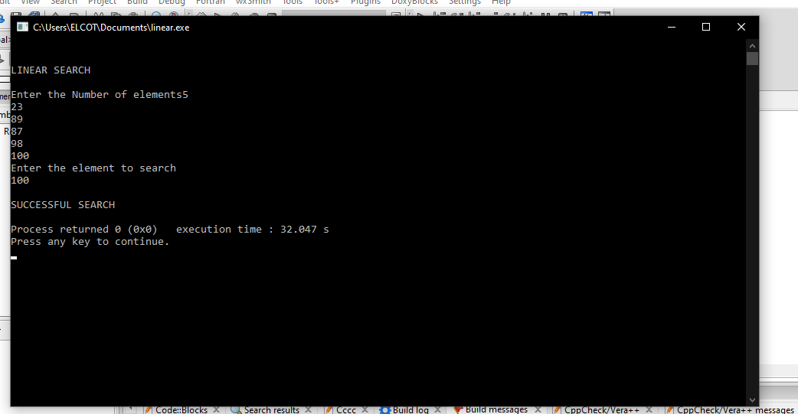
OUTPUT:

REG.NO: 22TD0053 NAME: MOHAMED B SIRAJUDDEEN YEAR/SEM/SEC: Y2/S3/B
BINARY SEARCH
Source code:
#include<stdio.h>
int main()
{
int a[100],n,i,l,u,mid,flag=0,k;
printf("\n\n BINARY SEARCH\n\n");
printf("Enter the Number of elements :");
scanf("%d",&n);
printf("Enter the elements :\n");
for(i=0;i<n;i++)
{
scanf("%d",&a[i]);
}
printf("Enter the element to search\n");
scanf("%d",&k);
l=0;
u=n;
while((flag!=1)&&(l<u))
{
mid=(l+u)/2;
if(k==a[mid])

{
flag=1;
printf("\nSUCCESSFUL SEARCH\n");
}
if(k<a[mid])
{
u=mid-1;
}
else
{
l=mid+1;
}
}
if(flag==0)
{
printf("\nUNSUCESSFUL SEARCH\n");
}
return 0;
}

OUTPUT:
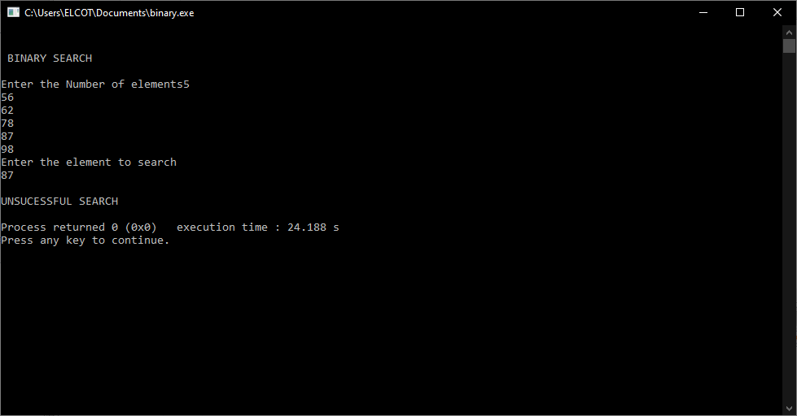

REG.NO: 22TD0053 NAME: MOHAMED B SIRAJUDDEEN YEAR/SEM/SEC: Y2/S3/B
INSERTION SORT
Source code
#include<stdio.h>
int main()
{
int a[100],i,j,n,temp,k;
printf("\n\nINSERTION SORT\n\n");
printf("Enter Number of Elements \n");
scanf("%d",&n);
printf("Enter the elements \n");
for(i=0;i<n;i++)
{
scanf("%d",&a[i]);
}
for(i=1;i<n;i++)
{
temp=a[i];
j=i-1;
while((j>=0)&&(a[j]>temp))
{
a[j+1]=a[j];
j--;
}

a[j+1]=temp;
}
printf("\nSorted elements are\n");
for(i=0;i<n;i++)
{
printf("%d",a[i]);
printf("\n");
}
return 0;
}

OUTPUT:
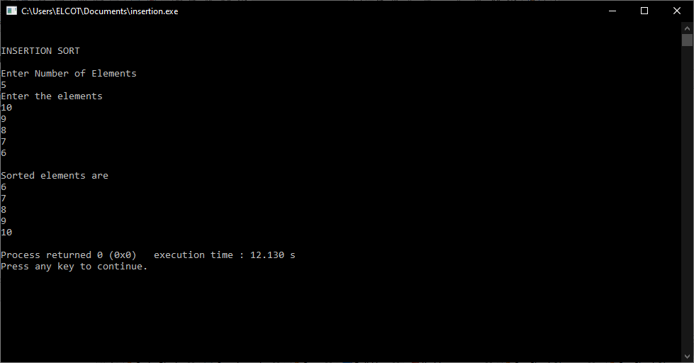

REG.NO: 22TD0053 NAME: MOHAMED B SIRAJUDDEEN YEAR/SEM/SEC: Y2/S3/B
SELECTION SORT
Source code
#include<stdio.h>
int main()
{
int a[100],i,j,n,temp,min;
printf("\n\nSELCTION SORT\n\n");
printf("Enter Number of Elements \n");
scanf("%d",&n);
printf("Enter the elements \n");
for(i=0;i<n;i++)
{
scanf("%d",&a[i]);
}
for(i=0;i<n-1;i++)
{
min=i;
for(j=i+1;j<n;j++)
{
if(a[j]<a[min])

{
min=j;
}
}
if(min!=i)
{
temp=a[min];
a[min]=a[i];
a[i]=temp;
}
}
printf("\nSorted elements of selction sort are\n");
for(i=0;i<n;i++)
{
printf("%d",a[i]);
printf("\n");
}
return 0;
}

OUTPUT:
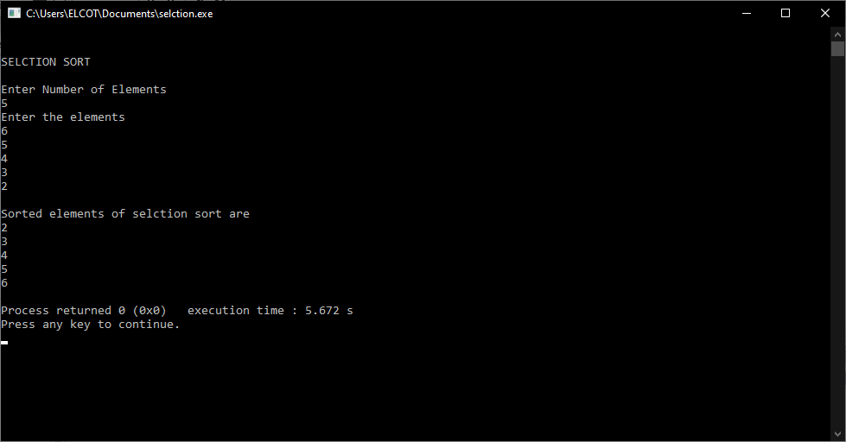

REG.NO: 22TD0053 NAME: MOHAMED B SIRAJUDDEEN YEAR/SEM/SEC: Y2/S3/B
SHELL SORT
Source code:
#include<stdio.h>
int main()
{
int a[100],i,n,temp,flag=1,gap;
printf("\n\nSHELL SORT\n\n");
printf("Enter Number of Elements \n");
scanf("%d",&n);
printf("Enter the elements \n");
for(i=0;i<n;i++)
{
scanf("%d",&a[i]);
}
gap=n/2;
while(flag==1||gap>1)
{
flag=0;
gap=(gap+1)/2;
for(i=0;i<n-gap;i++)
{
if(a[i]>a[i+gap])
{
temp=a[i];

a[i]=a[i+gap];
a[i+gap]=temp;
flag=1;
}
}
}
printf("\nSorted elements of shell sort are\n");
for(i=0;i<n;i++)
{
printf("%d",a[i]);
printf("\n");
}
return 0;
}

OUTPUT:
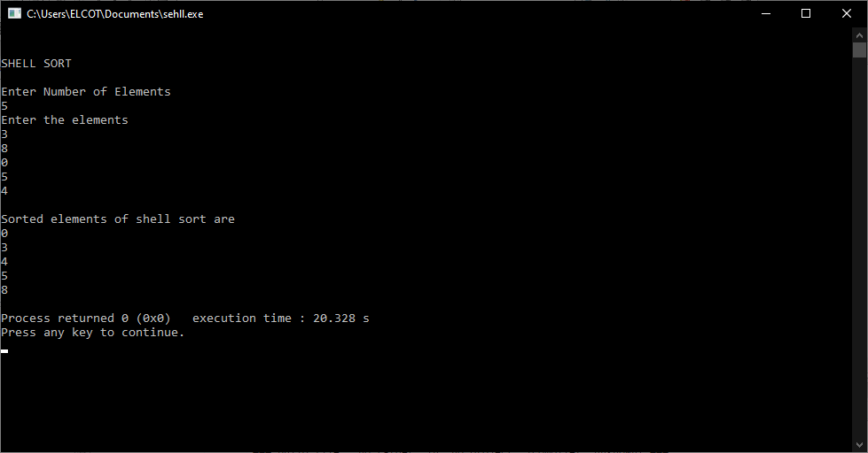

REG.NO: 22TD0053 NAME: MOHAMED B SIRAJUDDEEN YEAR/SEM/SEC: Y2/S3/B
BUBBLE SORT
Source code
#include<stdio.h>
int main()
{
int a[100],i,j,n,temp;
printf("\n\nBUBBLE SORT\n\n");
printf("Enter Number of Elements \n");
scanf("%d",&n);
printf("Enter the elements \n");
for(i=0;i<n;i++)
{
scanf("%d",&a[i]);
}
for(i=0;i<n-1;i++)
{
for(j=0;j<n-i-1;j++)
{
if(a[j]>a[j+1])
{
temp=a[j];
a[j]=a[j+1];
a[j+1]=temp;

}
}
}
printf("\nSorted elements of bubble sort are\n");
for(i=0;i<n;i++)
{
printf("%d",a[i]);
printf("\n");
}
return 0;
}

OUTPUT:
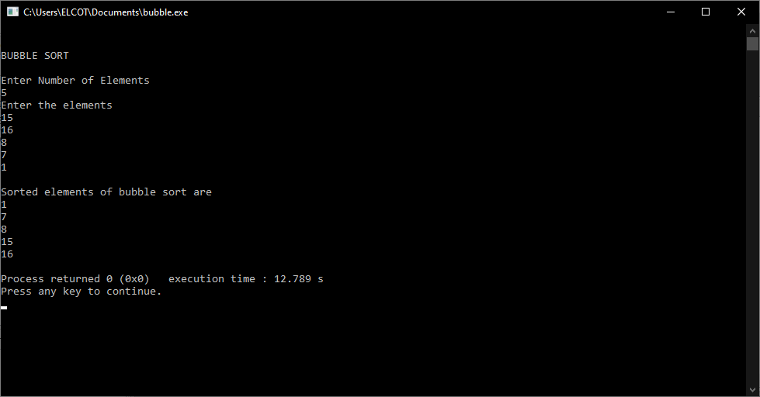

REG.NO: 22TD0053 NAME: MOHAMED B SIRAJUDDEEN YEAR/SEM/SEC: Y2/S3/B
RADIX SORT
Source code
#include<stdio.h>
int main()
{
int a[100][100],r=0,c=0,i,n,b[50],temp;
printf("\n\n RADIX SORT\n\n");
printf("Size of array:");
scanf("%d",&n);
for(r=0;r<100;r++)
{
for(c=0;c<100;c++)
{
a[r][c]=100;
}
}
for(i=0;i<n;i++)
{
printf("Enter element %d:",i+1);
scanf("%d",&b[i]);

r=b[i]/100;
c=b[i]%100;
a[r][c]=b[i];
}
printf("sorted elements of radix sort are");
for(r=0;r<100;r++)
{
for(c=0;c<100;c++)
{
for(i=0;i<n;i++)
{
if(a[r][c]==b[i])
{
printf("\n %d",a[r][c]);
}
}
}
}
return 0;
}

OUTPUT:
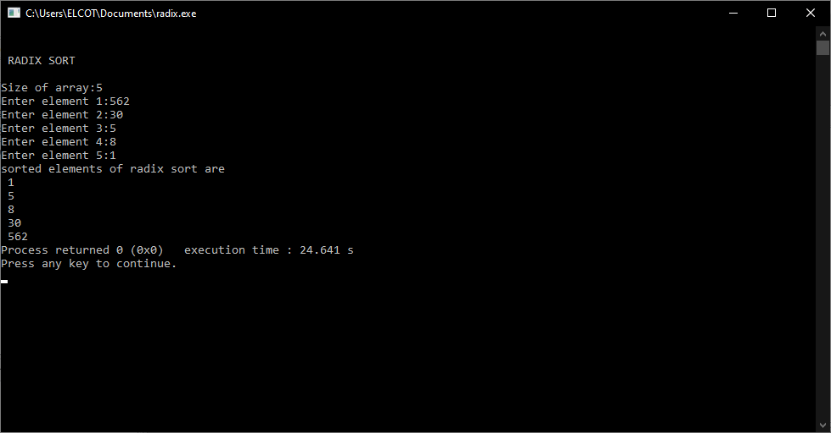

REG.NO: 22TD0053 NAME: MOHAMED B SIRAJUDDEEN YEAR/SEM/SEC: Y2/S3/B
QUICK SORT
Source code
#include<stdio.h>
void quick(int a[],int ,int );
int main()
{
int a[100],n,i,p,q;
printf("\n\nQUICK SORT \n");
printf("Enter the Size of Array:");
scanf("%d",&n);
printf("\nEnter the elements :\n");
for(i=0;i<n;i++)
{
scanf("%d",&a[i]);
}
p=0;
q=n-1;
quick(a,p,q);
printf("sorted elements of quick sort are \n");
for(i=0;i<n;i++)
{
printf("%d\n",a[i]);
}
return 0;

}
void quick(int a[],int s,int b)
{
int p,i,j,temp;
if(s<b)
{
p=a[s];
i=s;
j=b;
while(i<j)
{
while(a[i]<=p&&i<b)
{
i++;
}
while(a[j]>p)
{
j--;
}
if(i<j)
{
temp=a[i];
a[i]=a[j];
a[j]=temp;
}

}
temp=a[s];
a[s]=a[j];a[j]=temp;
quick(a,s,j-1);
quick(a,j+1,b);
}
}

OUTPUT:
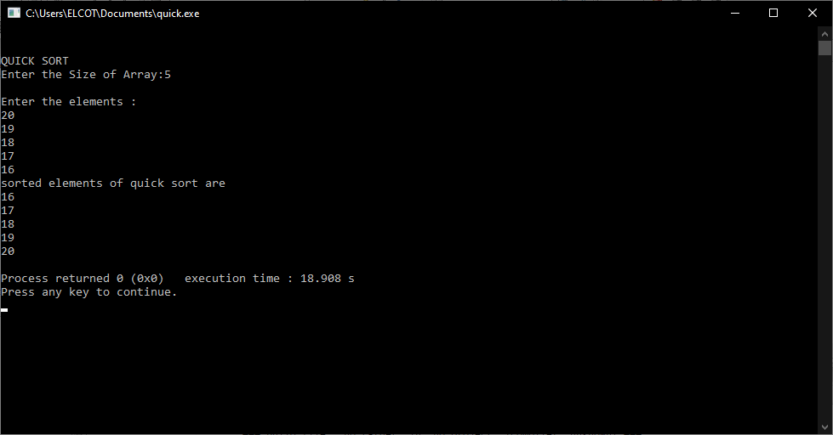

REG.NO: 22TD0053 NAME: MOHAMED B SIRAJUDDEEN YEAR/SEM/SEC: Y2/S3/B
MERGE SORT
Source code :
#include<stdio.h>
void mergesort(int,int);
void mergesort(int,int);
void merge(int,int,int);
int a[10],n;
void main()
{
int i,low,high,k;
printf(" MERGE SORT");
printf("\nEnter the number of elements:");
scanf("%d",&n);
printf("\nEnter the elements:\n");
for(i=1;i<=n;i++)
{
scanf("%d",&a[i]);
}
low=1;
high=n;
mergesort(low,high);
printf("\nThe sorted list is:");
for(k=1;k<=n;k++)

{
printf("\n%d",a[k]);
}
}

void mergesort(int low,int high)
{
int mid;
if(low<high)
{
mid=((low+high)/2);
mergesort(low,mid);
mergesort(mid+1,high);
merge(low,mid,high);
}
}

void merge(int low,int mid,int high)
{
int i,j,h,b[10],k;
h=low;
i=low;
j=mid+1;

while((h<=mid)&&(j<=high))
{
if(a[h]<=a[j])
{
b[i]=a[h];
h=h+1;
}
else
{
b[i]=a[j];
j=j+1;
}
i=i+1;
}
if(h>mid)
{

for(k=j;k<=high;k++)
{
b[i]=a[k];
i++;
}
}

else
{
for(k=h;k<=mid;k++)
{
b[i]=a[k];
i++;
}
}
printf("\nsorting process order");
for(k=low;k<=high;k++)
{
a[k]=b[k];
printf(" %d",a[k]);
}
}

OUTPUT:
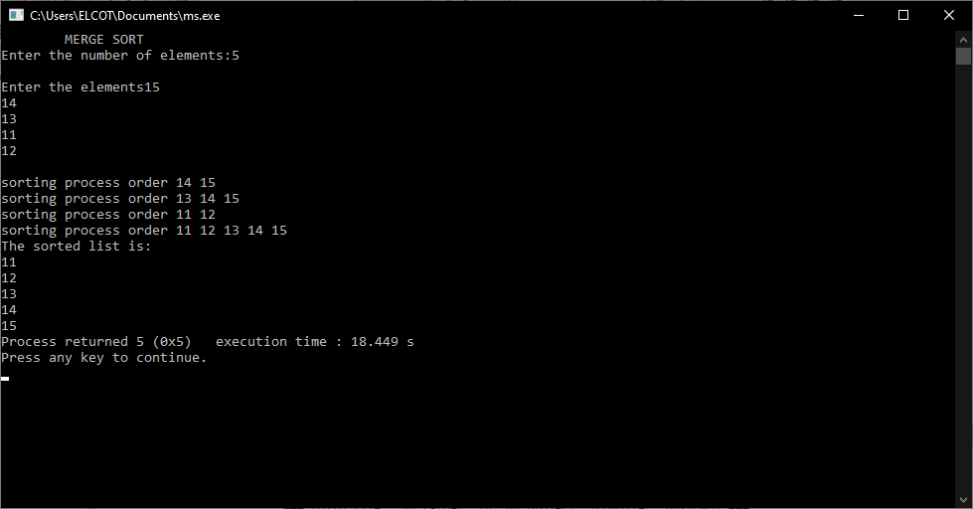

REG.NO: 22TD0053 NAME: MOHAMED B SIRAJUDDEEN YEAR/SEM/SEC: Y2/S3/B
CIRCULAR LINKED LIST
Source code :
#include<stdio.h>
int stack[100],choice,n,top,x,i;
void push(void);
void pop(void);
void display(void);
int main()
{
//clrscr();
top=-1;
printf("\n Enter the size of STACK:");
scanf("%d",&n);
printf("\n\t STACK OPERATIONS USING ARRAY");
printf("\n\t--------------------------------");
printf("\n\t 1.PUSH\n\t 2.POP\n\t 3.DISPLAY\n\t 4.EXIT");
do
{
printf("\n Enter the Choice:");
scanf("%d",&choice);
switch(choice)
{
case 1:
{
push();
break;

}
case 2:
{
pop();
break;
}
case 3:
{
display();
break;
}
case 4:
{
printf("\n\t EXIT POINT ");
break;
}
default:
{
printf ("\n\t Please Enter a Valid Choice(1/2/3/4)");
}

}
}
while(choice!=4);
return 0;
}
void push()
{
if(top>=n-1)
{
printf("\n\tSTACK is over flow");

}
else
{
printf(" Enter a value to be pushed:");
scanf("%d",&x);
top++;
stack[top]=x;
}
}
void pop()
{
if(top<=-1)
{
printf("\n\t Stack is under flow");
}
else
{
printf("\n\t The popped elements is %d",stack[top]);
top--;
}
}
void display()
{
if(top>=0)
{
printf("\n The elements in STACK \n");
for(i=top; i>=0; i--)
printf("\n%d",stack[i]);
printf("\n Press Next Choice");
}
else
{
printf("\n The STACK is empty");
}

}

OUTPUT:
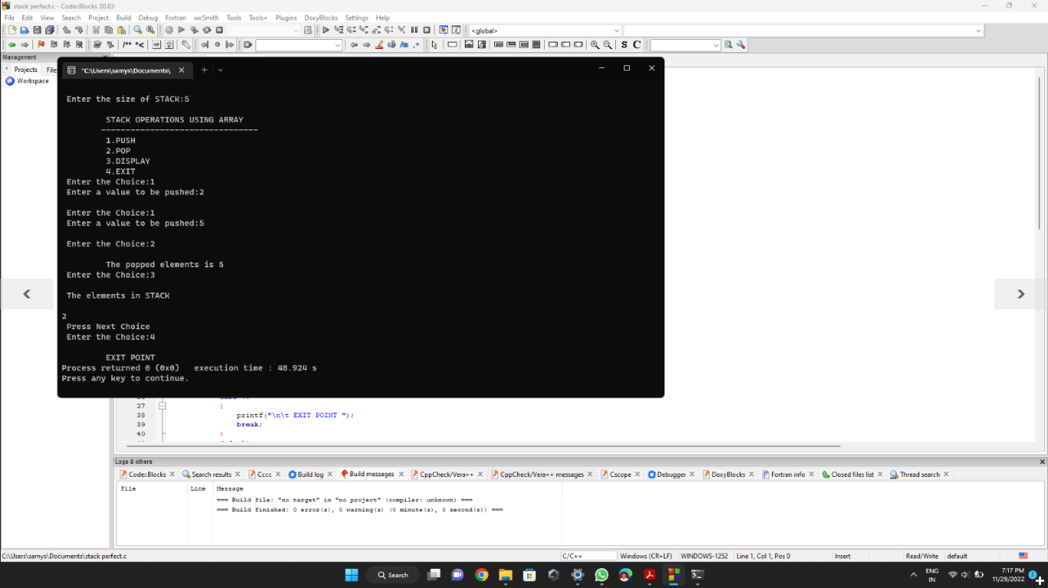

REG.NO: 22TD0053 NAME: MOHAMED B SIRAJUDDEEN YEAR/SEM/SEC: Y2/S3/B
EVALUATION OF EXPRESSION
Source code :
#include<stdio.h>
#include<math.h>
void main()
{
char expr[100];
int expr_ind=0;
int stack[100];
int top=-1;
int a=0,b=0;
printf("\n Enter the expression:");
scanf("%s",expr);
while(expr[expr_ind]!='\0')
{
if(expr[expr_ind]>='0'&&expr[expr_ind]<='9')
{
top++;
stack[top]=expr[expr_ind]-'0';
}

else
{
a=stack[top--];
b=stack[top];
switch(expr[expr_ind])
{
case'+':stack[top]=a+b;break;
case'-':stack[top]=a-b;break;
case'*':stack[top]=a*b;break;
case'%':stack[top]=a%b;break;
}
}
expr_ind++;
}
printf("\n The value of expression is %d",stack[top]);
}

OUTPUT:
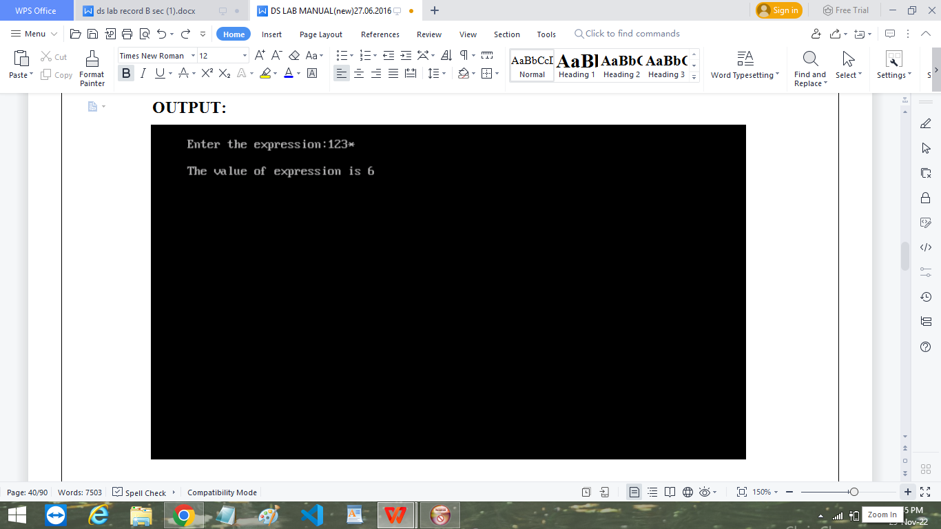

REG.NO: 22TD0053 NAME: MOHAMED B SIRAJUDDEEN YEAR/SEM/SEC: Y2/S3/B
QUEUE
Source code :
#include<stdio.h>
struct que
{
int data[30];
int front;
int rear;
};
struct que*ps;
int x,n,ch,n;
char opt;
void enqueue(struct que*ps,int x);
void dequeue(struct que*ps);
void display(struct que*ps);
void main()
{
ps=(struct que*)malloc(sizeof(struct que));
ps->rear=ps->front=-1;
printf("\n\t\t\tQUEUE\t\t\t\n");
printf("Enter the Limit:");

scanf("%d",&n);
while(1)
{
printf("1.ENQUEUE\n2.DISPLAY\n3.DEQUEUE\n4.EXIT\n");
printf("Enter your choice:");
scanf("%d",&ch);
switch(ch)
{
case 1:
enqueue(ps,x);
break;
case 2:
display(ps);
break;
case 3:
dequeue(ps);
break;
case 4:
exit(1);
break;
default:
printf("\nEnter a valid case\n");
break;

}
}
}
void enqueue(struct que*ps,int x)
{
if(ps->rear==n-1)
{
printf("\nQueue Overflow");
return;
}
printf("Enter the No. to be inserted into the Queue:");
scanf("%d",&x);
if(ps->rear==-1 && ps->front==-1)
{
ps->rear++;
ps->front++;
ps->data[ps->rear]=x;
}
else
{
ps->rear++;
ps->data[ps->rear]=x;
}

}
void display(struct que*ps)
{
int i;
if(ps->front==-1)
{
printf("\nQueue is Empty\n");
return;
}
else
printf("The Items of the queue:");
for(i=ps->front;i<=ps->rear;i++)
{
printf("\n%d\t",ps->data[i]);
}
}

void dequeue(struct que*ps)
{
if(ps->front==-1)
{
printf("Queue Underflow\n");
return;

}

if(ps->front > ps->rear)
{
printf("Queue Underflow\n");
return;
}
printf("Value Deleted:%d\t",ps->data[ps->front]);
ps->front++;
}

OUTPUT:
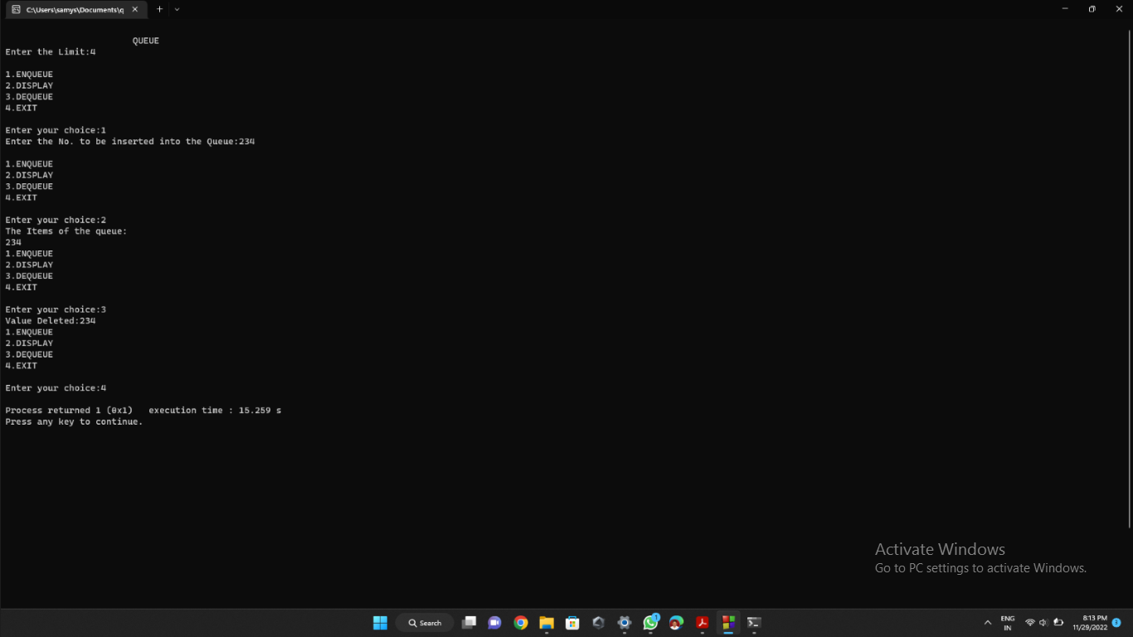

REG.NO: 22TD0053 NAME: MOHAMED B SIRAJUDDEEN YEAR/SEM/SEC: Y2/S3/B
CIRCULAR QUEUE
Source code :
#include<stdio.h>
#define max 5
int front,rear,q[max];
void enqueue();
void dequeue();
void qdisplay();
void main()
{
int c;
front=rear=-1;
do
{
printf("\n choose:- 1.Enqueue\t2.Dequeue\t3.Display\t4.Exit\nEnter your choice:");
scanf("%d",&c);
switch(c)
{
case 1:enqueue();break;
case 2:dequeue();break;
case 3:qdisplay();break;
case 4:printf("\n End");break;
default:printf("\n Wrong choice");break;
}
}while(c!=4);
getch();
}
void enqueue()
{
int x;
if((front==0&&rear==max-1)||(front==rear+1))
{
printf("\n Queue overflow");
}
if(front==-1)
{
front=rear=0;
}
else

{
if(rear==max-1)
{
rear=0;
}
else

{
rear++;
}
}
printf("\n Enter the number:");
scanf("%d",&x);
q[rear]=x;
}
void dequeue()
{
int y;
if(front==-1)
{
printf("\n Q is underflow");
}
y=q[front];
if(front==rear)
{
front=rear=-1;
}
else
{
if(front==max-1)

{
front=0;
}
else
{
front++;
}
}
printf("%d Successfully deleted",y);
}
void display()
{
int i;
if(front==rear==-1)
{
printf(" Q is empty");
}
printf("\n Elements are...");
for(i=front;i!=rear;i=(i+1)%max)
{
printf("%d\n",q[i]);
}
printf("%d \n",q[rear]); }

OUTPUT:
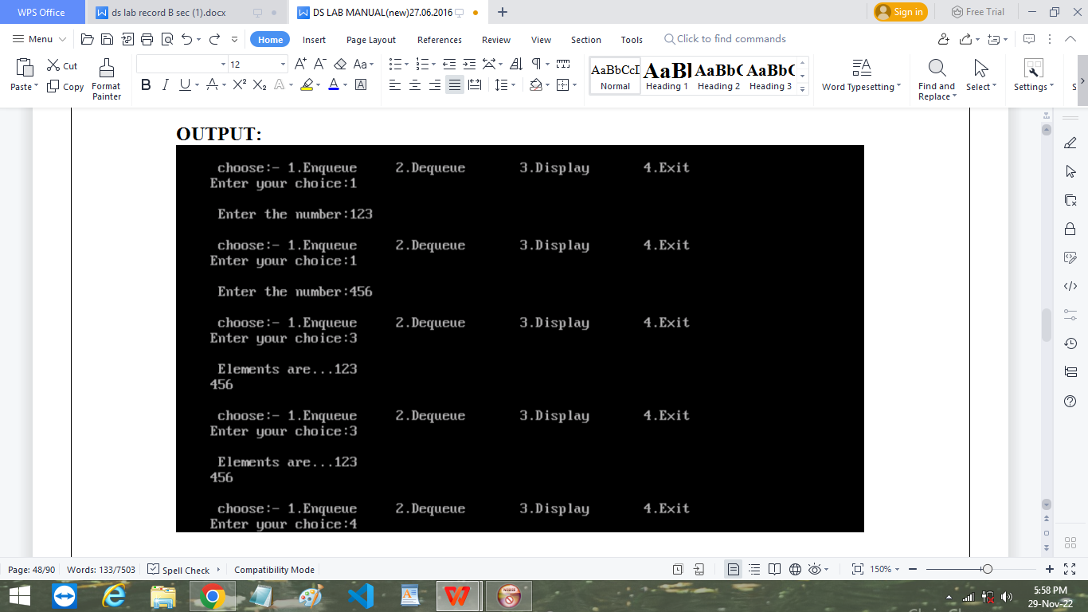

REG.NO: 22TD0053 NAME: MOHAMED B SIRAJUDDEEN YEAR/SEM/SEC: Y2/S3/B
DOUBLY LINKED LIST
Source code :
#include<stdio.h>
#include <stdlib.h>
struct doubly
{
struct doubly *front;
struct doubly *back;
int i;
};
void main()
{
struct doubly *head=0;
struct doubly *last=0;
struct doubly *p=0;
struct doubly *temp=0;
int ch,intch,user,cnt=0,t,add;
printf("\n\t 1. CREATE.");
printf("\n\t 2. INSERT.");
printf("\n\t 3. DELETE.");

printf("\n\t 4. DISPLAY.");
printf("\n\t 5.EXIT.");
scanf("%d",&ch);

while(ch!=5)
{
if(ch==1)
{
cnt=0;
head=(struct doubly *)malloc(sizeof(struct doubly));
head->back=0;
head->front=0;
printf("\n\t ENTER DATA::: ");
scanf("%d",&head->i);
cnt++;
last=head;
}
if(ch==2)
{

printf("\n\t 1. INSERTION AT FRONT.");

printf("\n\t 2. INSERTION AT MIDDLE.");
printf("\n\t 3. INSERTION AT END.");
scanf("%d",&intch);
temp=(struct doubly *)malloc(sizeof(struct doubly));
printf("\n\t ENTER DATA:::");
scanf("%d",&temp->i);

if(intch==1)
{
temp->front=0;
temp->back=head;
head=temp;
cnt++;
}
if(intch==3)
{
p=head;
while(p->back!=0)
{
p=p->back;
}

temp->back=0;
temp->front=p;
p->back=temp;
cnt++;
}
if(intch==2)
{
printf("\n\tENTER VALUE BETWEEN 1--%d",cnt);
scanf("%d",&add);
t=1;
p=head;
while(t<add)
{
p=p->back;
t++;
}
temp->back=p->back;
p->back->front=temp;
p->back=temp;
temp->front=p;

}
}
if(ch==4)
{
p=head;
while(p!=0)
{
printf("\t-->%d",p->i);
p=p->back;
}
printf("\n\t total nodes %d",cnt);
}
if(ch==3)
{
printf("\n\t1. DELETE FRONT");
printf("\n\t2. DELETE MIDDLE");
printf("\n\t3. DELETE END");
scanf("%d",&intch);
if(intch==1)
{

head->back=t;
free(head);
head=t;
head->front=0;
cnt--;
}
if(intch==3)
{
p=head;
while(p->back!=0)
{
p=p->back;
}
temp->front=p;
p->back=temp;
temp->back=0;
cnt--;
}
if(intch==2)
{
printf("\n\tENTER VALUE BETWEEN 1--%d",cnt);

scanf("%d",&add);
t=1;
p=head;
while(t<(add-1))
{
p=p->back;
t++;
}
temp=p->back;
p->back=temp->back;
temp->back->front=p;
free(temp);

}

}
printf("\n\t 2. INSERT.");
printf("\n\t 3. DELETE.");
printf("\n\t 4. DISPLAY.");
printf("\n\t 5.EXIT.");
scanf("%d",&ch); } }

OUTPUT:
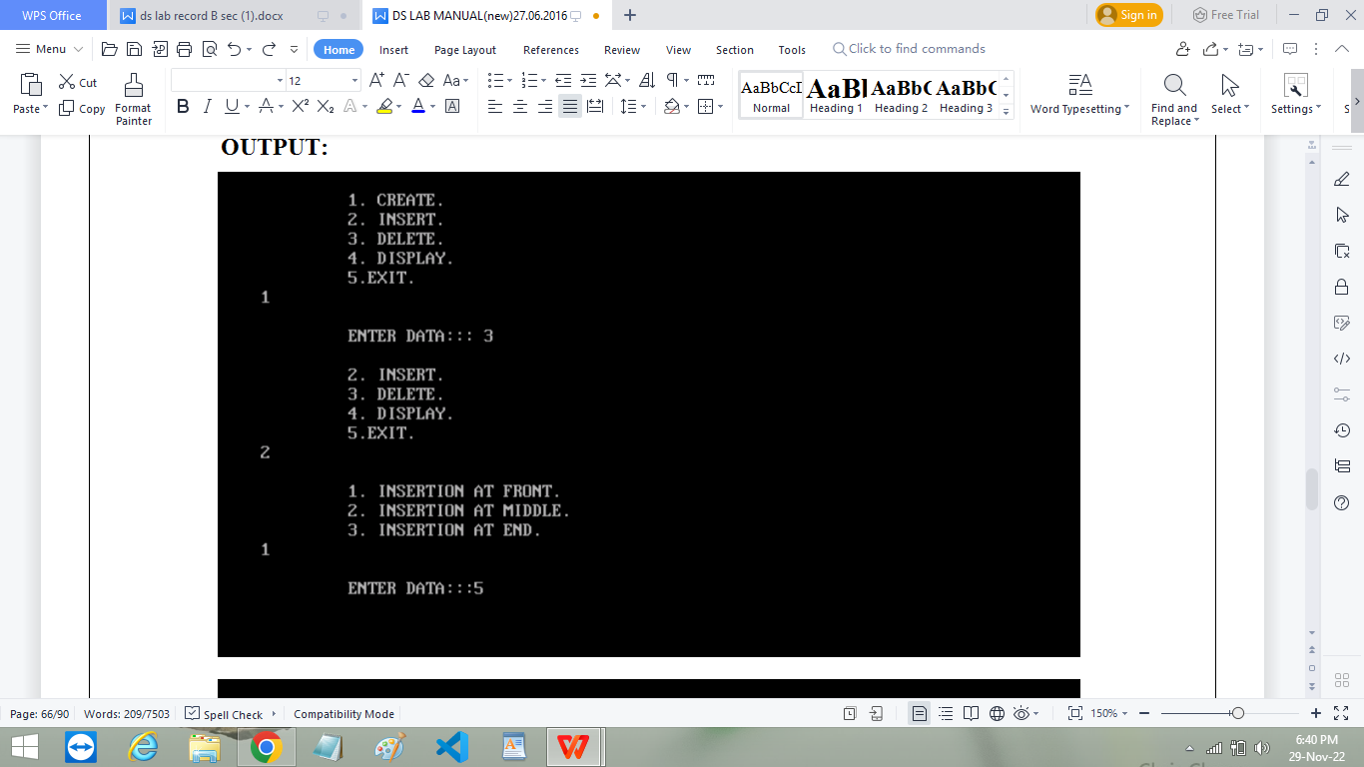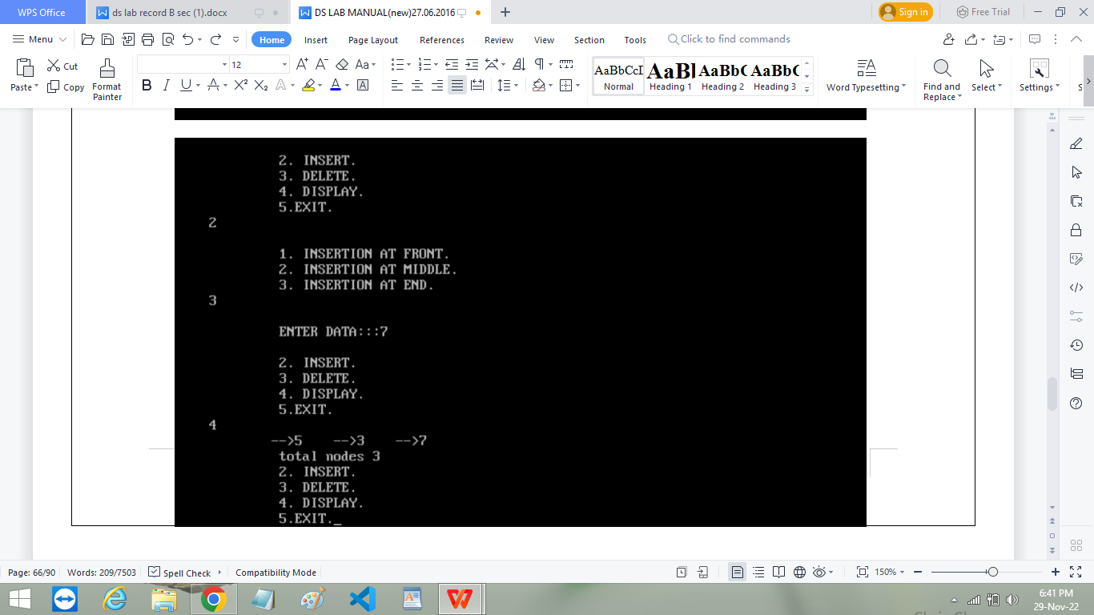

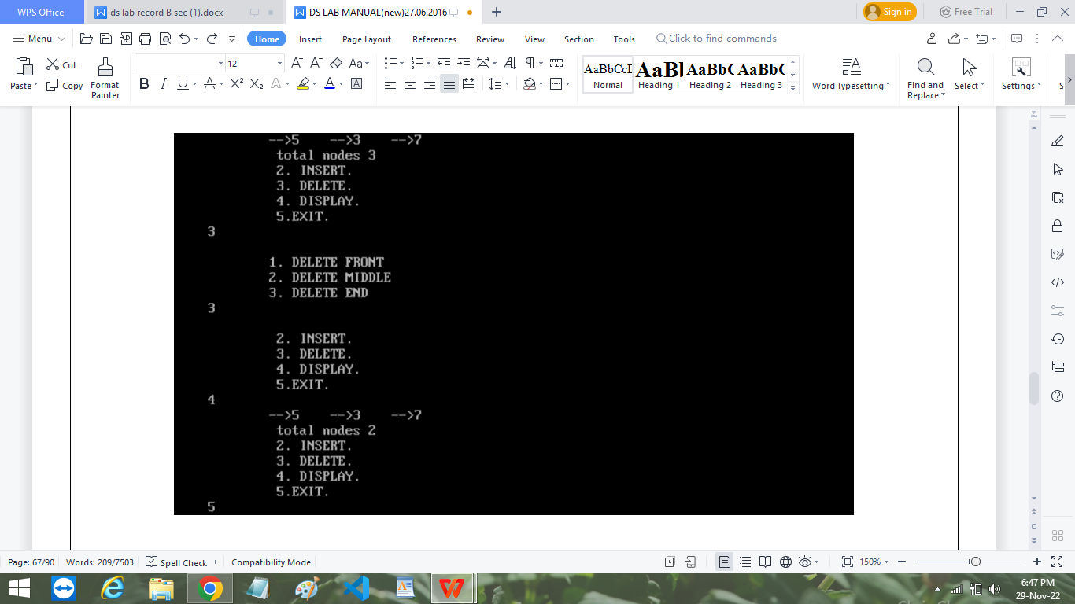

REG.NO: 22TD0053 NAME: MOHAMED B SIRAJUDDEEN YEAR/SEM/SEC: Y2/S3/B
CIRCULAR LINKED LIST
Source code :
#include<stdio.h>
#include<malloc.h>
struct node
{
int info;
struct node *next;
}*h;
void create(struct node *);
void insertfront(struct node *,int);
void insertmiddle(struct node *,int);
void insertend(struct node *,int);
void deletefront(struct node *);
void deletemiddle(struct node *);
void deleteend(struct node *);
void search(struct node *);
void display(struct node *);
void main()
{
struct node *h;

int n,s,op;
h=(struct node *)malloc(sizeof(struct node *));
printf("\n\n\n\n\t\t\t\t Linked list operation");
printf("\n\n\t1.Create\n\t2.Insert front\n\t3.Insert middle\n\t4.Insert end\n");
printf("\n\t5.Delete front\n\t6.Delete middle\n\t7.Delete end\n\t8.search\n\t9.Display\n\t10.Exit\n");
while(1)
{
printf("\n Enter your option:\t");
scanf("%d",&op);
switch(op)
{
case 1:create(h);break;
case 2:
printf("\n Enter the number to insert:\t");
scanf("%d",&n);
insertfront(h,n);
break;
case 3:
printf("\n Enter the number to insert:\t");
scanf("%d",&n);
insertmiddle(h,n);
break;

case 4:
printf("\n Enter the number to insert:\t");
scanf("%d",&n);
insertend(h,n);
break;
case 5:
deletefront(h);
break;
case 6:
deletemiddle(h);
break;
case 7:
deleteend(h);
break;
case 8:
search(h);
break;
case 9:
display(h);
break;
case 10:
exit(0);
break;

default:printf("\n.....Invalid option\n");
}
}
}
void create(struct node *h)
{
int i,n,x;
struct node *s1,*s2;
s1=(struct node *)malloc(sizeof(struct node *));
printf("\n Enter the number of elements:\t");
scanf("%d",&x);
printf("\n Enter the element:\t");
scanf("%d",&n);
s1->info=n;
s1->next=h;
h->next=s1;
for(i=0;i<x-1;i++)
{
s2=(struct node *)malloc(sizeof(struct node *));
s1->next=s2;
printf("\n Enter the element:\t");
scanf("%d",&n);
s2->info=n;

s2->next=h;
s1=s1->next;
}
display(h);
printf("\n");
}
void insertfront(struct node *h,int n)
{
struct node *x;
x=(struct node *)malloc(sizeof(struct node *));
x->info=n;
x->next=h->next;
h->next=x;
display(h);
printf("\n");
}
void insertmiddle(struct node *h,int n)
{
struct node *x,*y;
int e;
x=(struct node *)malloc(sizeof(struct node *));
x->info=n;
x->next=h;

printf("\n Enter the element after which the given element to be inserted:\t");
scanf("%d",&e);
y=h;
while(y->info!=e)
y=y->next;
x->next=y->next;
y->next=x;
display(h);
}
void insertend(struct node *h,int n)
{
struct node *x,*y;
x=(struct node *)malloc(sizeof(struct node *));
x->info=n;
x->next=h;
y=h;
while(y->next!=h)
y=y->next;
y->next=x;
display(h);
}
void deletefront(struct node *h)
{

if(h->next!=h)
h->next=h->next->next;
else
h=h;
display(h);
}
void deletemiddle(struct node *h)
{
int e;
struct node *x,*y;
y=h;
x=y->next;
printf("\n Enter the element \t");
scanf("%d",&e);
while(x->info!=e)
{
x=x->next;
y=y->next;
}
y->next=x->next;
display(h);
}
void deleteend(struct node *h)

{
struct node *x,*y;
y=h;
x=y->next;
while(x->next=h)
{
x=x->next;
y=y->next;
}
y->next=h;
display(h);
}
void search(struct node *h)
{
struct node *x,*y;
int s;
printf("\n Enter the number:\t");
scanf("%d",&s);
y=h;
while(y->info!=s&&y->next!=h)
y=y->next;
if(y->info==s)
printf("Element found\n");

else
printf("Element not found \n");
}
void display(struct node *h)
{
struct node *y;
y=h;
printf("h->");
while(y->next!=h)
{
y=y->next;
printf("%d->",y->info);
}
printf("h");
}

OUTPUT:
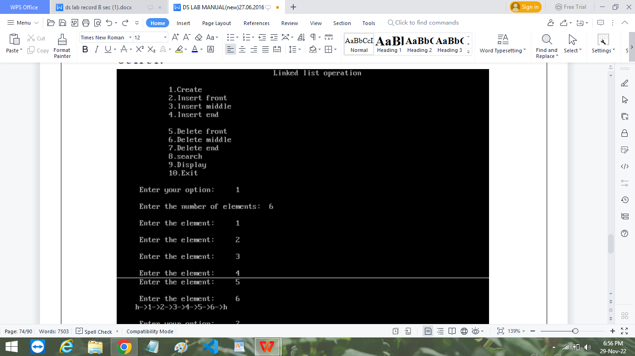
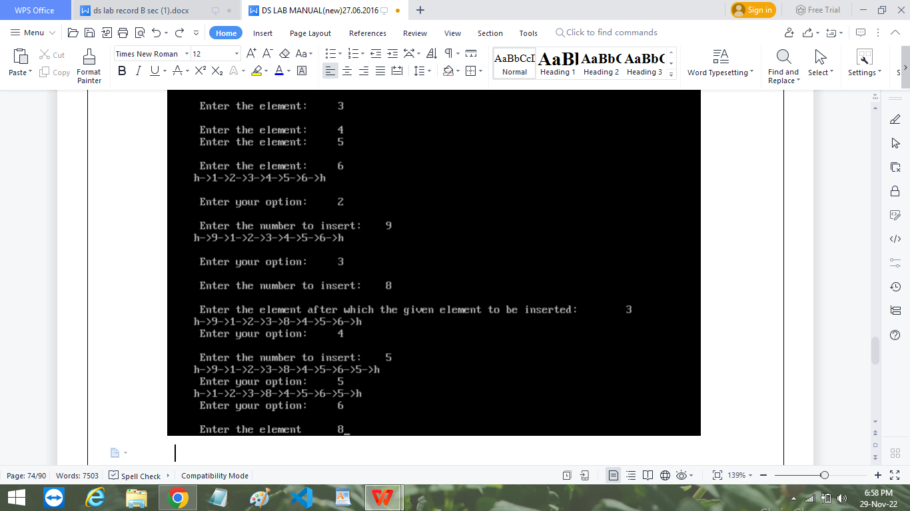

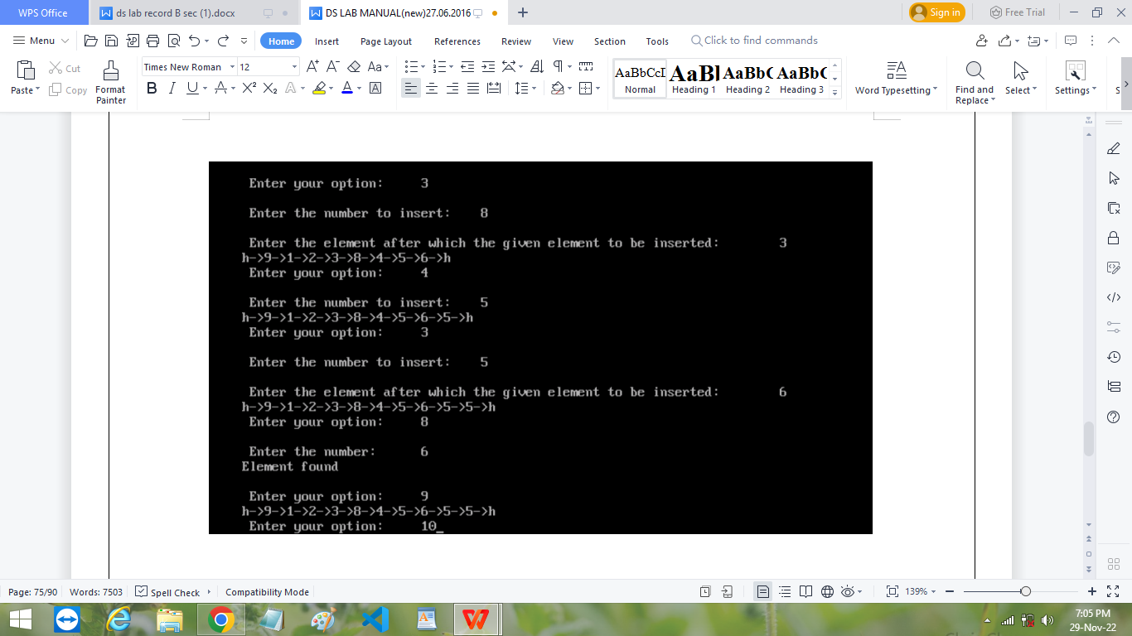

REG.NO: 22TD0053 NAME: MOHAMED B SIRAJUDDEEN YEAR/SEM/SEC: Y2/S3/B
TREE TRAVERSAL
Source code :
#include<stdio.h>
#include<malloc.h>
struct node
{
int value;
struct node*left,*right;
};
struct node*root,*new1;
void insert(struct node*,struct node*);
void preorder(struct node*);
void inorder(struct node*);
void postorder(struct node*);
int main()
{
int ch,v;
root=(struct node*)malloc(sizeof(struct node));
printf("Enter the value of root:");
scanf("%d",&root->value);
root->left=root->right=NULL;

printf("\n\t.......TREE TRAVERSAL....\n\t");
printf("\n\t1.insert\n\t2.preorder\n\t3.postorder\n\t4.inorder\n\t5.exit");
while(1)
{
printf("\n enter your option:");
scanf("%d",&ch);
switch(ch)
{
case 1:
new1=(struct node*)malloc(sizeof(struct node));
printf("Enter the value to be inserted\t");
scanf("%d",&new1->value);
new1->left=new1->right=NULL;
insert(root,new1);
break;
case 2:
printf("\n pre order traversal:");
preorder(root);
break;
case 3:
printf("\n post order traversal:");
postorder(root);
break;

case 4:
printf("\n in order traversal:");
inorder(root);
break;
case 5:
exit(0);
break;
}
}
}

void preorder(struct node*root)
{
if(root!=NULL)
{
printf("\n%d",root->value);
preorder(root->left);
preorder(root->right);
}
}

void inorder(struct node*root)
{

if(root!=NULL)
{
inorder(root->left);
printf("\n%d",root->value);
inorder(root->right);
}
}

void postorder(struct node*root)
{
if(root!=NULL)
{
postorder(root->left);
postorder(root->right);
printf("\n%d",root->value);
}
}
void insert(struct node*root,struct node*new1)
{
if(new1->value<root->value)
{
if(root->left==NULL)
root->left=new1;

else
insert(root->left,new1);
}
if(new1->value>root->value)
{
if(root->right==NULL)
root->right=new1;
else
insert(root->right,new1);
}
}

OUTPUT:
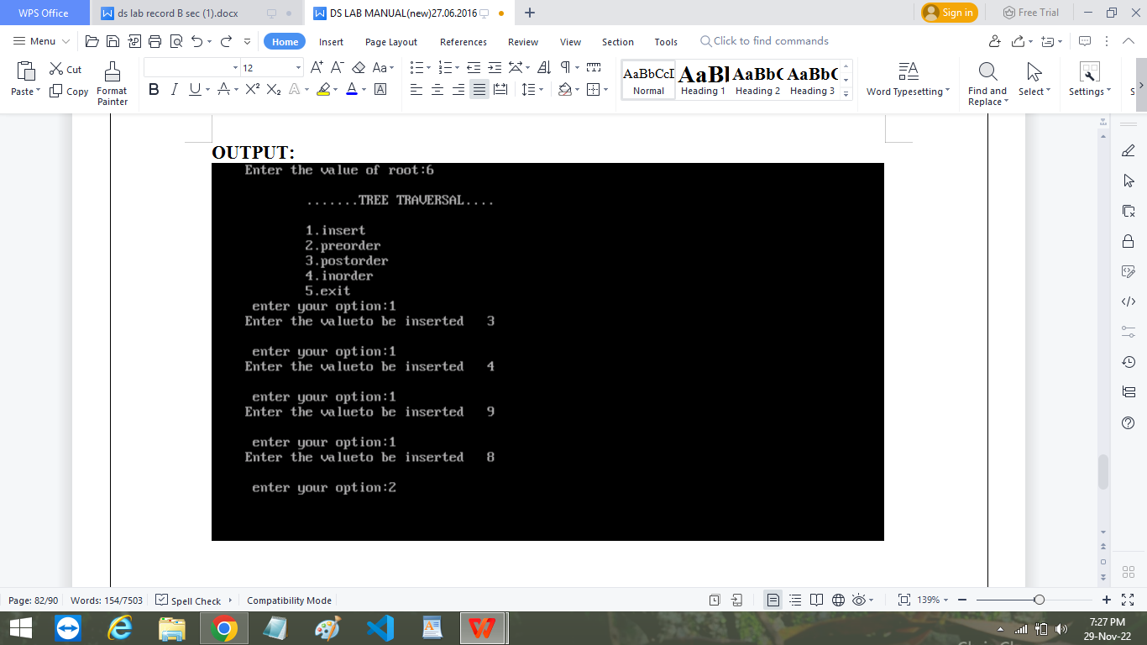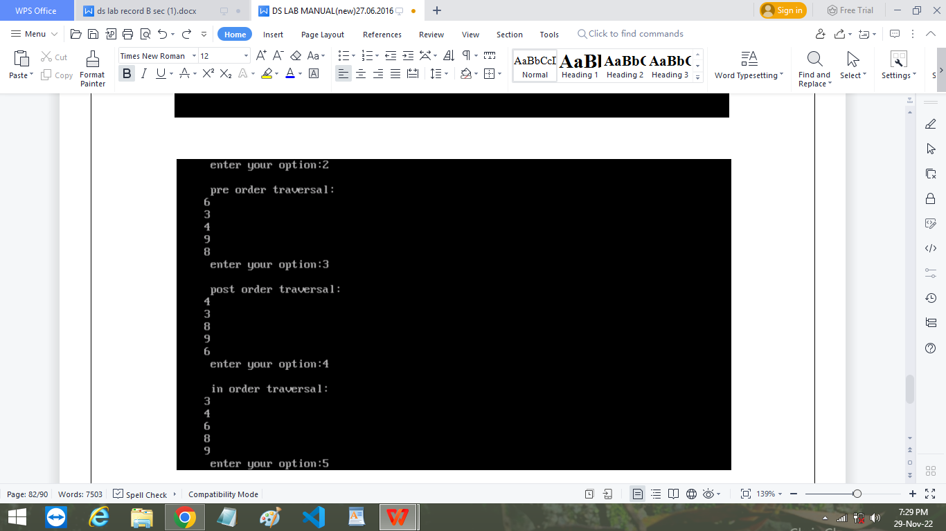

REG.NO: 22TD0053 NAME: MOHAMED B SIRAJUDDEEN YEAR/SEM/SEC: Y2/S3/B
BREADTH FIRST SEARCH
Source code :
#include<stdio.h>
int a[20][20],q[20],visited[20],n,i,j,f=0,r=-1;
void bfs(int v)
{
for(i=1;i<=n;i++)
if(a[v][i] && !visited[i])
q[++r]=i;
if(f<=r)
{
visited[q[f]]=1;
bfs(q[f++]);
}
}
void main()
{
int v;
printf("\n Enter the number of vertices:");
scanf("%d",&n);
for(i=1;i<=n;i++)

{
q[i]=0;
visited[i]=0;
}
printf("\n Enter graph data in matrix form:\n");
for(i=1;i<=n;i++)
for(j=1;j<=n;j++)
scanf("%d",&a[i][j]);
printf("\n Enter the starting vertex:");
scanf("%d",&v);
bfs(v);
printf("\n The node which are reachable are:\n");
for(i=1;i<=n;i++)
if(visited[i])
printf("%d\t",i);
getch():
}

OUTPUT:
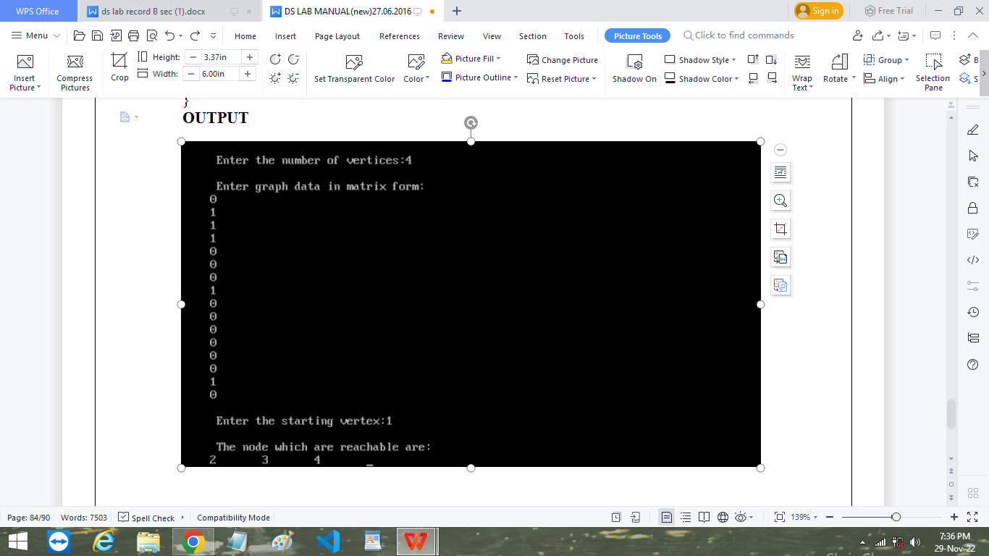

REG.NO: 22TD0053 NAME: MOHAMED B SIRAJUDDEEN YEAR/SEM/SEC: Y2/S3/B
DEPTH FIRST SEARCH
Source code :
#include<stdio.h>
int a[20][20],reach[20],n;
void dfs(int v)
{
int i;
reach[v]=1;
for(i=1;i<=n;i++)
if(a[v][i] && !reach[i])
{
printf("\n %d->%d",v,i);
dfs(i);
}
}
void main()
{
int i,j,count=0;
printf("\n Enter number of vertices:");
scanf("%d",&n);
for(i=1;i<=n;i++)

{
reach[i]=0;
for(j=1;j<=n;j++)
a[i][j]=0;
}
printf("\n Enter the adjacency matrix:\n");
for(i=1;i<=n;i++)
for(j=1;j<=n;j++)
scanf("%d",&a[i][j]);
dfs(1);
printf("\n");
for(i=1;i<=n;i++)
{
if(reach[i])
count++;
}
if(count==n)
printf("\n Graph is connected");
else
printf("\n Graph is not connected");
getch();
}

OUTPUT:
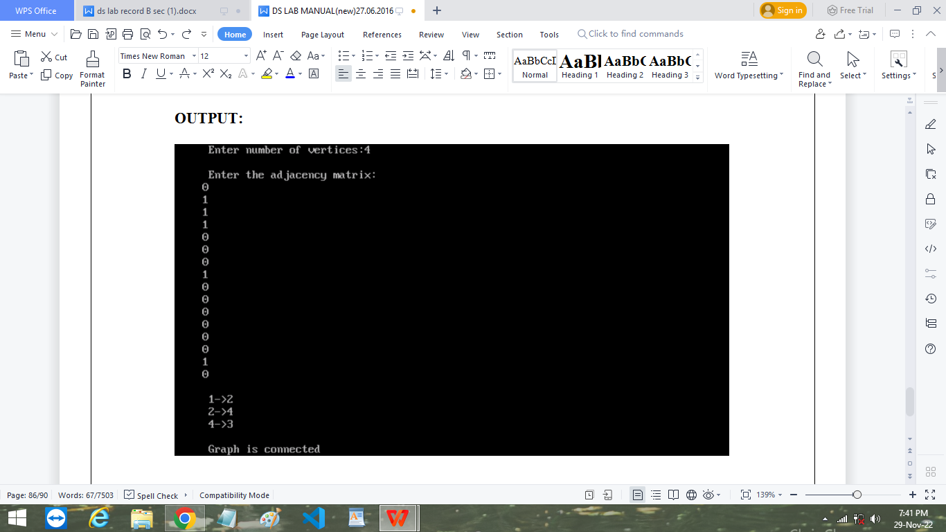

REG.NO: 22TD0053 NAME: MOHAMED B SIRAJUDDEEN YEAR/SEM/SEC: Y2/S3/B

DIJKSTRA’S ALGORITHM
Source code :
#include<stdio.h>
#define INFINITY 9999
#define MAX 10

void dijkstra(int G[MAX][MAX],int n,int startnode);

int main()
{
int G[MAX][MAX],i,j,n,u;
printf("Enter no. of vertices:");
scanf("%d",&n);
printf("\nEnter the adjacency matrix:\n");
for(i=0;i<n;i++)
for(j=0;j<n;j++)
scanf("%d",&G[i][j]);
printf("\nEnter the starting node:");
scanf("%d",&u);
dijkstra(G,n,u);
return 0;

}

void dijkstra(int G[MAX][MAX],int n,int startnode)
{

int cost[MAX][MAX],distance[MAX],pred[MAX];
int visited[MAX],count,mindistance,nextnode,i,j;
//pred[] stores the predecessor of each node
//count gives the number of nodes seen so far
//create the cost matrix
for(i=0;i<n;i++)
for(j=0;j<n;j++)
if(G[i][j]==0)
cost[i][j]=INFINITY;
else
cost[i][j]=G[i][j];
//initialize pred[],distance[] and visited[]
for(i=0;i<n;i++)
{
distance[i]=cost[startnode][i];
pred[i]=startnode;
visited[i]=0;
}

distance[startnode]=0;
visited[startnode]=1;
count=1;
while(count<n-1)
{
mindistance=INFINITY;
//nextnode gives the node at minimum distance
for(i=0;i<n;i++)
if(distance[i]<mindistance&&!visited[i])
{
mindistance=distance[i];
nextnode=i;
}
//check if a better path exists through nextnode
visited[nextnode]=1;
for(i=0;i<n;i++)
if(!visited[i])
if(mindistance+cost[nextnode][i]<distance[i])
{
distance[i]=mindistance+cost[nextnode][i];
pred[i]=nextnode;
}
count++;

}
//print the path and distance of each node
for(i=0;i<n;i++)
if(i!=startnode)
{
printf("\nDistance of node%d=%d",i,distance[i]);
printf("\nPath=%d",i);
j=i;
do
{
j=pred[j];
printf("<-%d",j);
}while(j!=startnode);
}
}

OUTPUT:
